**experiment program coding basics**

At the time of writing there are three types of experiment program:

|  |  |
| --- | --- |
| **Type** | **Main use** |
| AveragerProgram + acquire_decimated() | Debugging, tof calibrate, etc. |
| AveragerProgram + acquire() | Measurement, with few variables to sweep. |
| RAveragerProgram + acquire() | Measurement, with several variables to sweep. |

Following I will detail more for each type.

Type1: AveragerProgram + acquire_decimated()

I will mostly follow the demo notebook “00_Send_receive_pulse.ipynb” on qick’s official github repository as an example, which uses the *axis_signal_gen_v6* as sg (signal generator), and *axis_readout_v2* as sr (signal reader). Examples of using other sg and sr can be found in the section *ip*.

We first import packages & load bitstream:

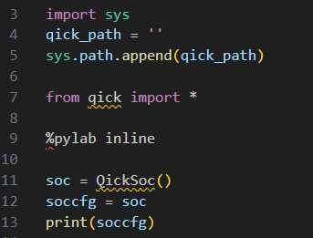

**Line4**: qick_path is the directory where you place the downloaded qick repository.

**Line11**: create an QickSoc object and load default bitstream distributed with qick’s repo. If you want to use other bitstream, you can replace this line11 with:

Soc = QickSoc(bitfile= bitfile_path)

Where bitfile_path is the path to the directory containing the bitstream file. Also notice that an companing .hwh file also need to be placed in the same directory (see the section *generate bitstream & load with pynq*).

**Line13**: Display firmware info, including dac, adc port mappings, clock speeds, buffer sizes, etc.

Next, define the program class as shown below. The class has two methods initialize() and body() which I will introduce later.

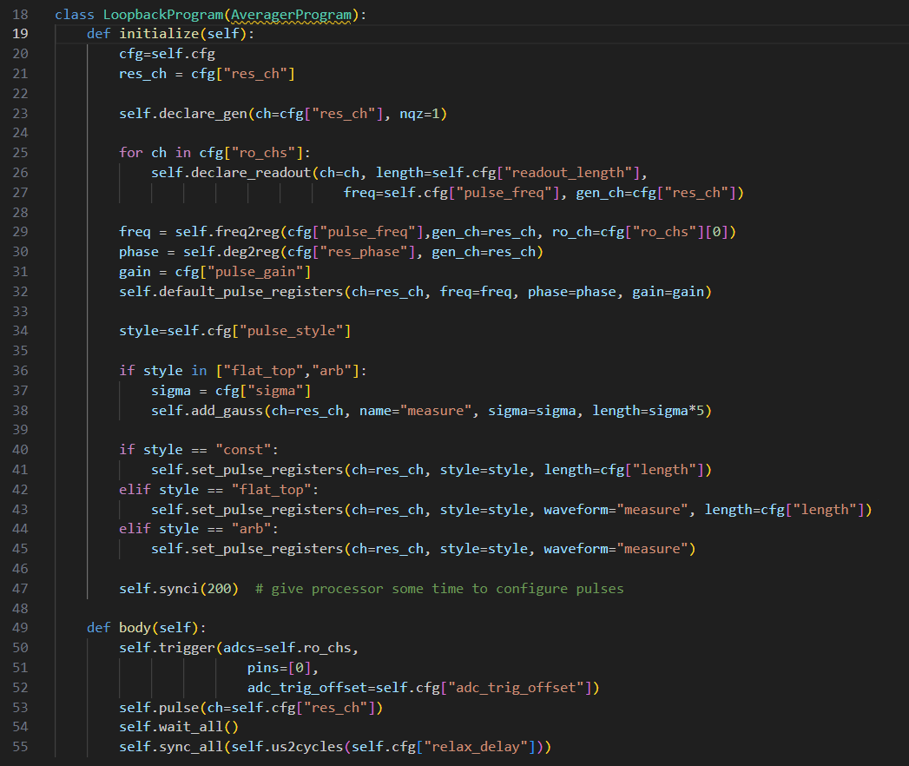

**Line19**: the contents inside initialize() will be converted to binary instructions as parts of tproc program, and will be executed once by tproc to initialize stuffs each time the tproc program runs. The tproc program will be run cfg[‘soft_avg’] number of times when you call acquire() (introduced later).

**Line20**: the cfg is as shown below, each quantity will be explained later.

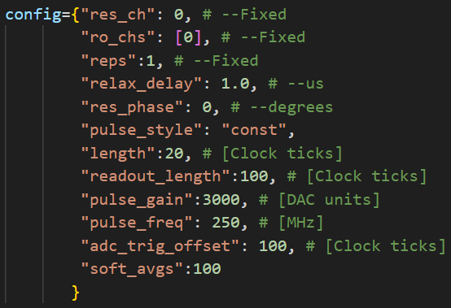

**Line23**: declare to use a signal generator. Need to pass it channel number (res_ch), and the nyquist zone of its output (see the section *sampling & re-construction*). The channel number info can be obtained from the firmware info (see Line13 explanation above) as follow:

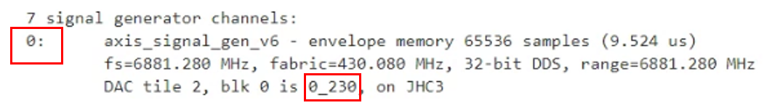

The ‘0’ is the virtual channel number and is filled in res_ch, and the ‘0_230’ is the physical channel number that you want to use to send RF signal and can be found on xm655 add-on card as shown below.

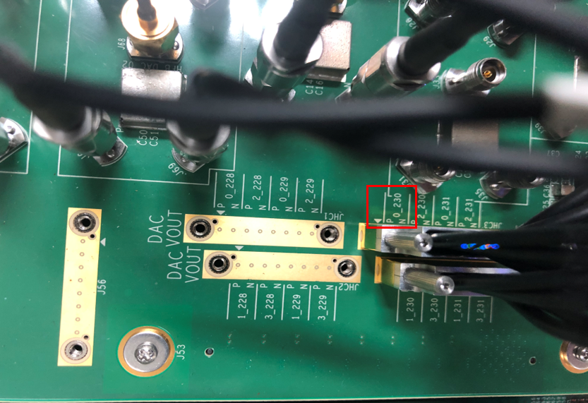

**Line25, 26, 27**: declare to use signal reader. The ro_chs can be similarly obtained as in Line23 explanation above. readout_length is length of signal to read in signal reader’s fabric clock cycle, which can be found as follow:

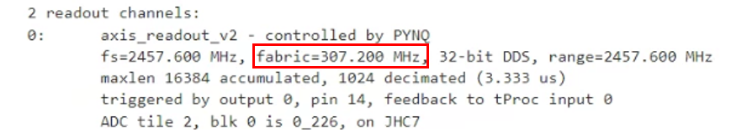

For example, if readout_length is 100, the length of the signal that will be readed is 100 / (ffabric * 106) = 325.5 ns. pulse_freq is the demodulation frequency. We also pass the channel of the signal generator whose signal this signal reader is trying to read to ensure frequency match. If there is a frequency mismatch, you won’t see consistent phase between acquisitions.

**Line29**: Convert pulse_freq (originally in MHz) to register value, which the logic circuit in fpga can process. We also need to pass signal generator and readers channel, res_ch and ro_chs, to ensure frequency match. pulse_freq is the carrier signal’s frequency at the output (of DAC or XM655). See the section *ip* for the valid pulse_freq range and resolution.

**Line30**: convert res_phase (originally in degree) to register value. res_phase is the phase offset relative to 0. See the section *ip* for the valid res_phase range and resolution.

**Line31**: pulse_gain is a multiplicative factor to the signal just before coming out from the sg. See the section *ip* for the valid pulse_gain range and resolution.

**Line32**: see the doc for axis_signal_gen_v6 in the section *ip* for details about *pulse registers*.

**Line36 ~ 45**: There are three build-in pulse styles: square (const), gaussian square (flat_top), gaussian (arb) as shown below.

|  |  |  |
| --- | --- | --- |
| const | flat_top | gauss |
|  |  |  |

Note that the time between two successive data points is 1/fs, where fs is the DAC sampling freq:

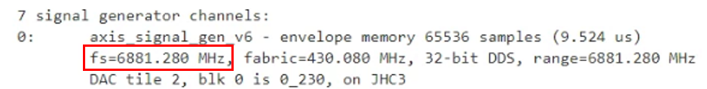

Note also that the arb can be used to implement arbitrary envelope and not just gaussian, and the way you do this is by setting pulse_style to be “arb” and replacing line36 ~ 38 with:

self.add_envelope(ch, name, idata = my_data)

where my_data is your arbitrary waveform data and it is a 1D array.

At line38, we add a gaussian envelope (as shown below) into table memory in sg (see the doc for axis_signal_gen_v6 in the section *ip*). The quantities sigma, length are all in fabric clock ticks of the sg. *name* can be arbitrarily but need to match the *waveform* used in set_pulse_registers() to be introduced later. At line40 ~ 45 we write some quantities to pulse registers (see the doc for axis_signal_gen_v6 in the section *ip*).

**Line47**: offset the reference time forward by 200, tnew = told + 200, and the specified timings for all the operations that follows (t in self.pulse(), adc_trig_offset in self.trigger(), etc) will be with respect to tnew.

**Line49**: each method invocation in body() will be converted to one or more binary instructions as parts of tproc program, and all of them will be executed by tproc by cfg[‘reps’] number of times continuously in fpga without software intervention (therefore is fast) and then the tproc binary program will end. The tproc program will be run cfg[‘soft_avg’] number of times when you call acquire() (introduced later).

**Line50~52**: Command the tproc to fire square trigger pulse at time tnew + adc_trig_offset, both in tproc clock ticks, which can be found in firmware info as shown below. The tnew is introduce earlier in Line47 explanation.

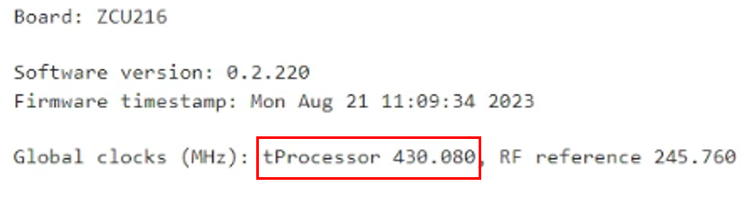

Two square trigger pulses will be fired, one is internal to fpga from tproc ip directly go to readout buffer ip (adcs=self.ro_chs), the other can go to other external instruments through pin 0 of PMOD on zcu216 (pins=[0]).

There are two PMOD’s on zcu216:

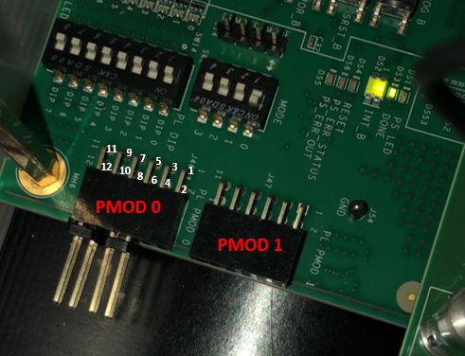

PMOD 1 is used to allow us to trigger tproc to start running program from outside, PMOD